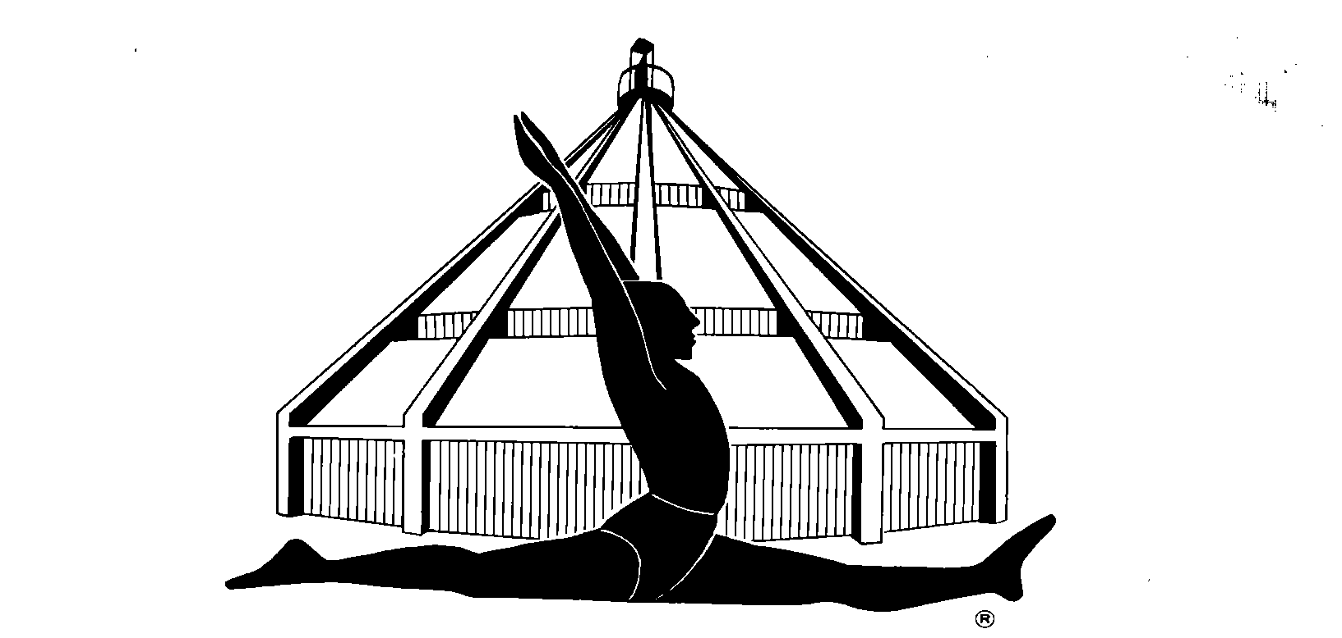

BKS IYENGAR YOGA ASSOCIATION (VANCOUVER)

WORKSHOP BURSARY REQUEST AND APPLICATION FORM
A limited number of bursaries are available to students and teachers (including teachers in training) who attend workshops sponsored by the BKS Iyengar Yoga Association (Vancouver). Currently there are two bursaries available for each of these categories of applicant per workshop. The bursary amount for each individual is half the fee of the workshop. Applicants are eligible to receive a workshop bursary every second year.

PREREQUISITES
The applicant must:
-­‐ be a member in good standing of the BKS Iyengar Yoga Association (Vancouver);
-­‐ be currently attending weekly yoga classes with a certified Iyengar Yoga teacher;
-­‐ submit this form endorsed by their recommending teacher. Bursary applications are accepted up to two weeks prior to the workshop.

Name: Date:

Address:

Email: Phone:

Please check one: Student Teacher in Training Certified Teacher Workshop teacher and date:
Have you received a bursary in the past? Yes No

If yes, please list the teacher(s) and date(s) for which you have previously received a bursary.

Teachers and teachers in training: please list professional development funds awarded in the past 5 years.

RECOMMENDING TEACHER

Name: Date:

Comments:

Application Procedure

-­‐Submit your request after completing registration for the workshop you wish to attend. Applications can be emailed to bksiyengarvan@gmail.com or mailed to: BKS Iyengar Yoga Association (Workshop Bursary), P.O. Box 60639 Granville Park Post Office, Vancouver BC, V6H 4B9.

You will be advised prior to the workshop if the request is accepted. A cheque for half the workshop fees will be provided during the workshop. In the event of the student cancelling their attendance to the workshop, the bursary will not be awarded and the student will be eligible to reapply for a future workshop.

-­‐Please note: Applications are considered on a first come-­‐first served basis. Preference will be given to applicants who are applying for the first time.

October 2019

